De Tre Största Flaskhalsarna

Rendering
Thread shell sort this thing is bad
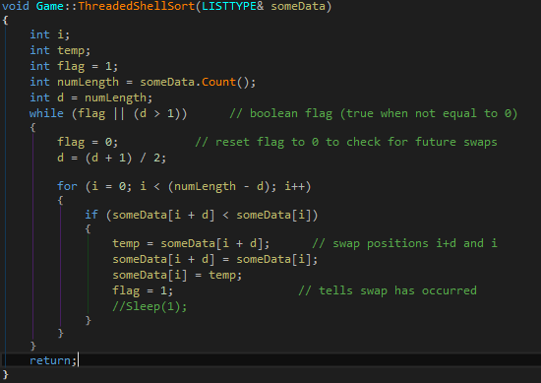
Render
Loopar igenom antal element istället för pixlar, gg eZ!
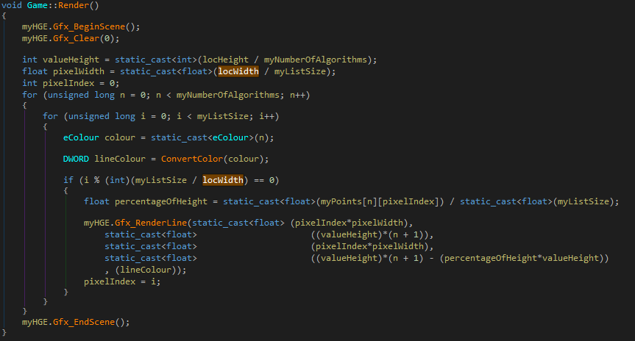

This fix it
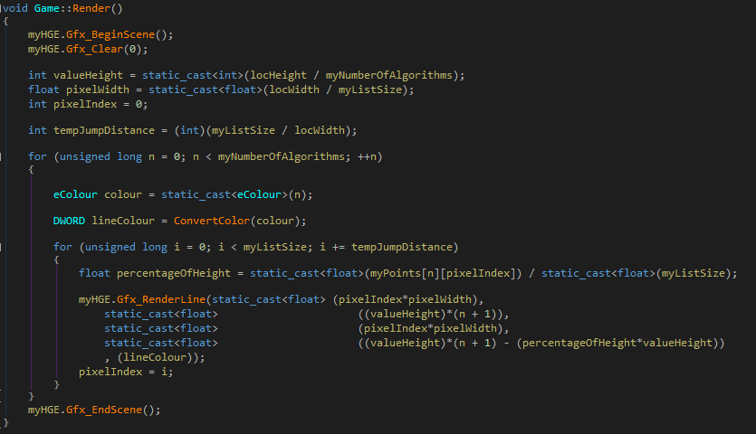
Heap sort sometimes get stuck... lots of work on nothing. FLASKHALS!
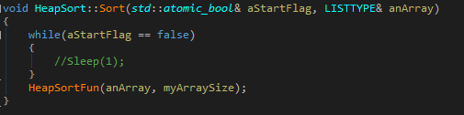

Load Time Debug
To fix load time, init with elementsize instead to avoid resize.
